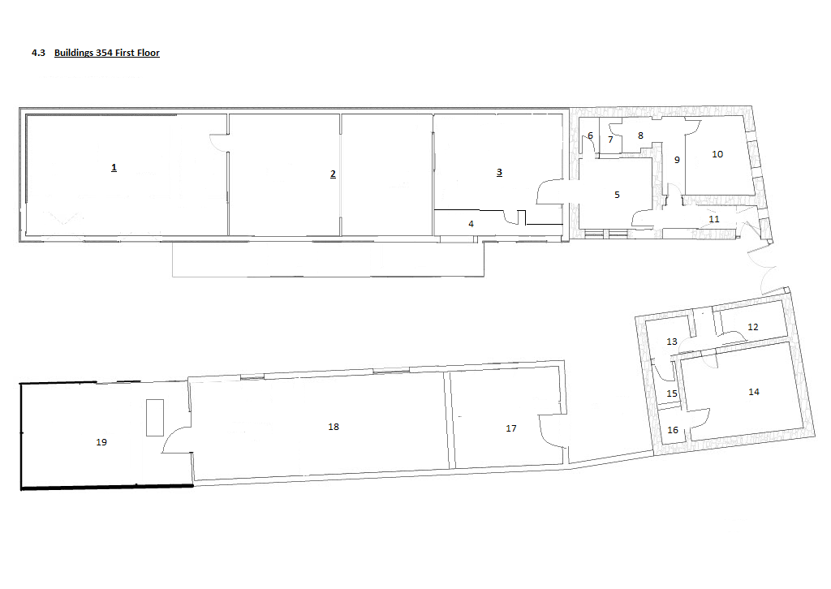

Nr | Name | Surface (m² )
1 | Attic above Cold Rooms | 87.6
2 | Production Facility | 81.2
3 | Office | 40.8
4 | Archive nr. 2 | 10
5 | Office | 20
6 | Archive nr. 1 | 3
7 | Office bathroom | 3
8 | Office kitchen | 3.2
9 | Corridor | 5.2
10 | Tasting room | 21
11 | Stairs | 6.2
12 | Dining Flat | 10
13 | Kitchen Flat | 6.2
14 | Bedroom flat | 30
15 | Bathroom flat | 7
16 | Pantry flat | 5
17 | Cardboard store | 32
18 | Tray store | 70
19 | Tray store | 50.8

